Tracking Antisemitism and Harm Across the United States

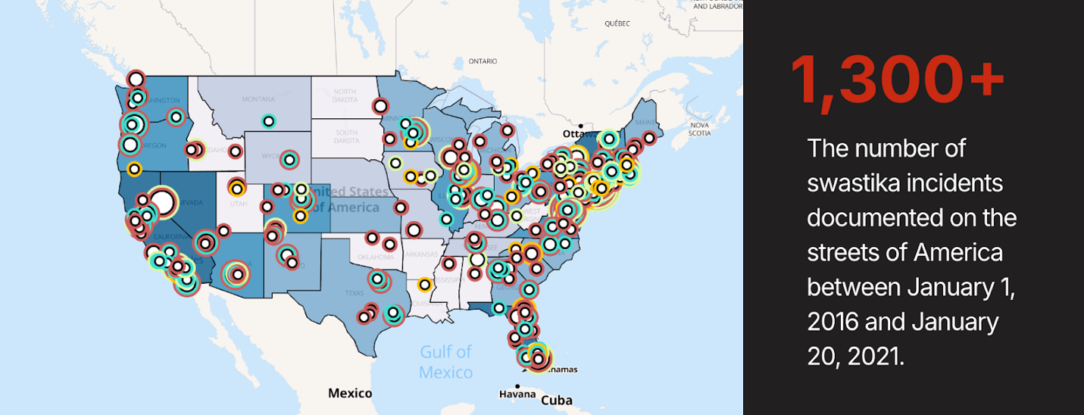

New public humanities project led by researchers at the University of Colorado offers insights into the location, nature, and targeted communities of swastika incidents that occurred in the U.S. between January 2016 and January 2021.

The Swastika Counter Project documented over 1300 swastika incidents that were reported during this time period by various sources such as newspapers, religious media outlets, social media, and online community platforms. Researchers spent 5 years recording, coding, analyzing, and mapping these swastika incidents to better understand the swastika’s contemporary functions in the United States.

Laurie Gries, the project director, emphasizes that it is important to recognize that swastikas have historically circulated and still do circulate for benevolent reasons for many cultures and communities. However, this project began in early 2017 when Dr. Gries started noticing swastika incidents being reported almost every day in online news sources. “This was at the same time,” she explains, “when various sources (news outlets, the FBI, etc.) were reporting rising incidents of hate and bias in the United States, when Donald Trump and his racist and divisive rhetoric was just coming into political power, and when white nationalist organizations seemed to be coming out of the woodwork.” Dr. Gries, a visual rhetoric scholar at CU Boulder, wanted to know who swastikas were targeting, how they were functioning, and, ultimately, if and how they might be contributing to a seeming intensification of white supremacist actions on the streets of the United States.

Key findings from the Swastika Counter Project’s research include:
- Between January 2016 and January 2021, swastika incidents occurred in all 48 contiguous states and the District of Columbia. Commonly targeted locations include religious institutions, public parks, private property, and local businesses. However, higher education institutions and K-12 schools were the most frequently targeted locations.
- The Jewish community received the largest brunt of swastika attacks. Black Americans and many other historically underrepresented individuals were also and often targeted, indicating how antisemitism in the contemporary United States enacts widespread multi-directional hate and violence.
- Information about perpetrators of swastika incidents is limited due to lack of eye witnesses, reporting practices, and other factors. Yet, locations of swastika incidents, such as schools, suggest that many perpetrators may be quite young. Data also indicates that in the incidents for which demographic details are available, offenders are most often male and white.
- Words and phrases often accompanied swastikas, and the content of these verbal expressions varied from political identifications and condemnations to racist and homophobic slurs to explicit threats of physical and genocidal violence. In the text corpus, the following words were most popular: Trump, White, N***** Jew(s), Power, and KKK.
- Swastika incidents documented between 2016 and 2020 by online local, national, educational, and religious sources were most often referred to as vandalism and graffiti. Less common was the identification of swastikas incidents as antisemitism and/or racism.
Based on these findings, Dr. Gries and project co-director, Dr. Wheeler, want people to better understand the close links between antisemitism, white supremacy, and white nationalism. Because swastikas are surfacing in so many K-12 schools and higher education institutions, they especially hope to encourage more education about how both ancient signs such as swastikas and new signs invented and appropriated by Neo-Nazis and white nationalist organizations are contributing to longstanding efforts to maintain white power in the United States.

The mission of the Swastika Counter Project, however, is to “both count and counter the contemporary proliferation of swastika incidents in the United States.”

Toward these efforts, the Swastika Counter Project has created an extensive website where visitors will find an interactive map spearheaded by CU Professor Morteza Karimzadeh and implemented by his former geography student Jason Miller. Visitors will also find graphs, data sets, and educational resources to use for research, teaching, activism, advocacy, or other communicative needs. In doing so, the Swastika Counter Project contributes to other projects tracking antisemitism and hate run by organizations such as the AMCHA, the Anti-defamation League, and the Southern Poverty Law Center.

The Swastika Counter Project also aims to help various community stakeholders respond to swastika incidents in informed and constructive ways. The website thus also includes two reports: an Executive Summary Report and a substantive report that analyzes the strengths and weaknesses of common community responses to swastika incidents.

This latter report largely grew out of Dr. Wheeler’s dissertation research, which disclosed that while many communities are taking constructive actions, many stakeholders struggle to identify best practices for both addressing and preventing future swastika incidents. In light of this predicament, the Swastika Counter Project’s Community Response Report offers six recommendations to help community stakeholders come together in coordinated action to both address and prevent swastika incidents.

Dr. Gries and Dr. Wheeler acknowledge the difficulty of adequately addressing antisemitism and its related, multiple kinds of oppression. But they say, “It is up to all of us–scholars, educators, activists, political leaders, police, and religious leaders–to come together to address this socio-cultural problem.” They hope that the Swastika Counter Project can play a small but important role in working toward such social justice aims.

